THE LOGIC FORGE ACTIVITY

Solution Outputs:

Problem1:
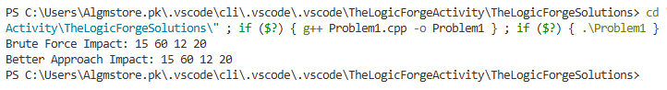
Problem2:
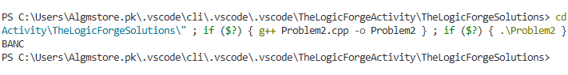
Problem3:
Problem4:
Problem5:

Problem6:

Problem 7:

